CAMPULUNG REMEMBERS……
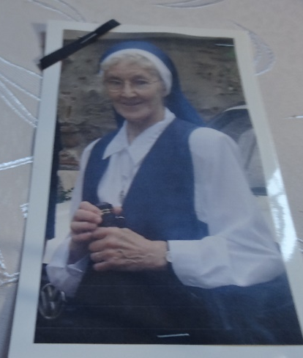
It was with great sadness that the sisters in Romania together with the parishioners of Campulung and Targoviste learned of the death of Sister Teresa Helena this week. Teresa Helena spent just over three years here in Campulung and ten years in Targoviste. But she had heard of Romania long before the Congregation started our mission here as a member of her family was a dealer for John Deere tractors, which are made in a factory near Brasov. She got very excited the first time she saw the factory.
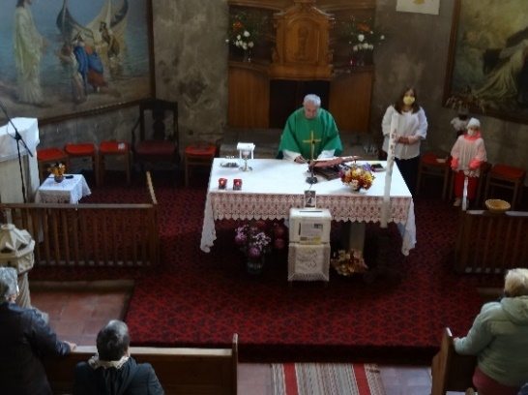
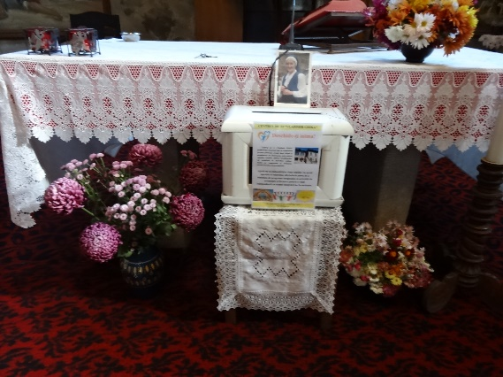
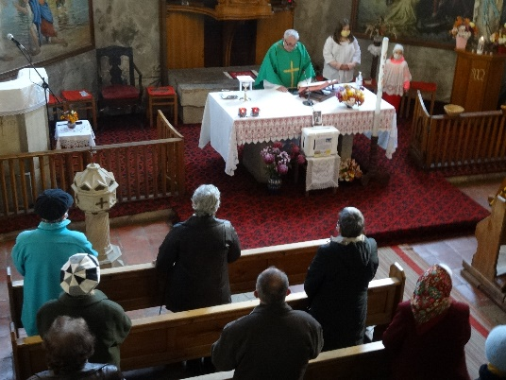
Our Sunday liturgy today, in Campulung, was celebrated in memory of Sister Teresa Helena. We thanked God for her presence here, for the many talents and gifts she shared with us all, and we asked God’s blessings on her and her family. Today’s gospel about the “talents” was very appropriate. I’m sure the Lord is saying to her: “Well done, good and faithful servant; you have shown you can be faithful in small things I will trust you with greater; come and join in your master’s happiness.” She is remembered for her deep faith and her belief in the Holy Spirit. Her parting words to the staff in Targoviste were; “Pray and rely on the Holy Spirit”. At the end of mass, the prayers usually said at the graveside, were also prayed here. During the month of November, our parishioners are invited to offer donations for the “Vladimir Ghika Centre” in memory of their dead. This day centre operates from a building where Teresa Helena once lived. In keeping with the Romanian tradition at funerals, food bags were distributed to the parishioners, as a form of alms giving, in memory of Sister Teresa Helena. This would normally be a meal but as in all situations worldwide we had to adjust to the present Covid restrictions. This food was prepared in the “Impreuna Restaurant”, part of the Caritas Project which was opened while Teresa Helena was living here in Campulung, and some of the food was from their farm including cheese made at the factory there, again often visited by Teresa Helena as we enjoyed summer barbecues.(Teresa Helena often said that as she was adjusting to the food and customs when she first came to Romania, cheddar cheese sent out from Selly Park saved her!) There were many such reminders during our celebration today and we felt her presence very near. May she rest in peace.
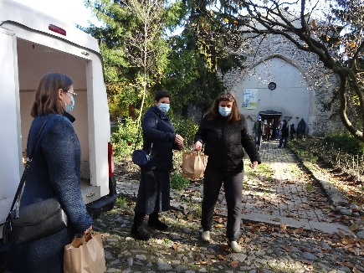
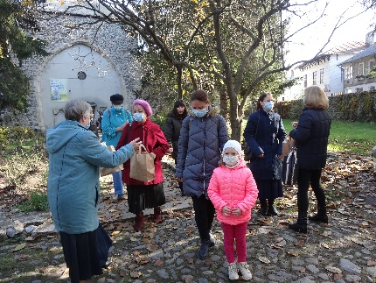
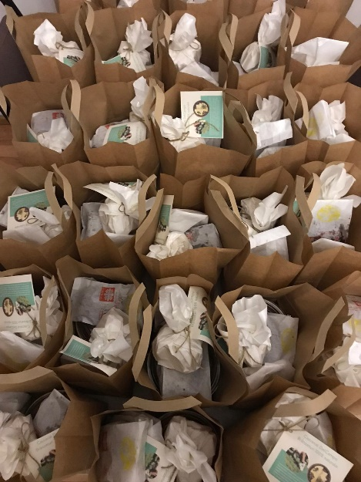
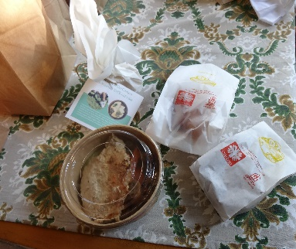

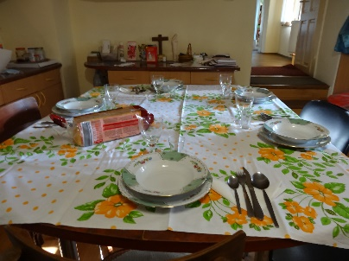
After mass the sisters were invited for lunch at the presbytery during which many stories of Sister Teresa Helena’s time in Campulung were shared.

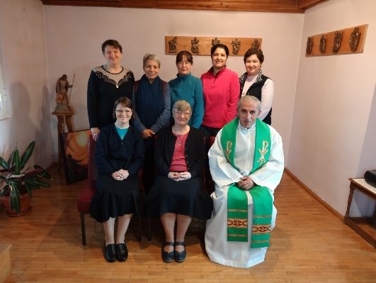
Condolences to Sister Kathleen, the leadership team, the Congregation and to Sister Teresa’s family on behalf of the Sisters in Romania and Fr. Paulet Petru.

