„BE SANTA FOR A CHILD WITH SPECIAL NEEDS!”

This is a charitable project, organised by the Day Centre ”Vladimir Ghika” and Special Educational School ”Sfântul Nicolae” Câmpulung, to take place from 20th November to 20th December 2021, for the children with special needs who attend both centres.
Why this project?
Because:
Each child is unique, is precious and has their own gifts and abilities. Recognizing the needs of each child requires patience and love, and each one of us needs togive them the opportunity to grow and develop in a stimulative and loving environment, especially in our
current society which is becoming more and more difficult and vulnerable.
We believe that through love and generosity we can change the future of children with special needs. In order to help them, under the motto "A gift offered, a dream come true!" the organisers and partners wanted to support these children with special needs, organising Christmas activities (eg. "A Christmas message for my special friend!", "Letter to Santa Claus"). Gifts such as toys, sweets, clothing, footwear, schoolsupplies, books and educational games were also provided.The project has had a positive impact not only locally but also nationally through the voluntary involvement of teachers, pupils and other generous people.Together, we succeeded in bringing the joy, light and warmth of Christmas to the lives of the children with special needs and their families.
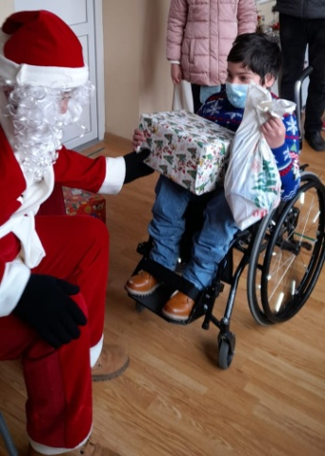
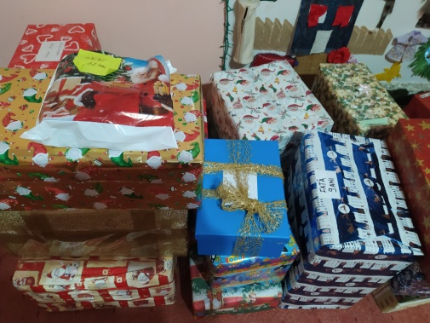
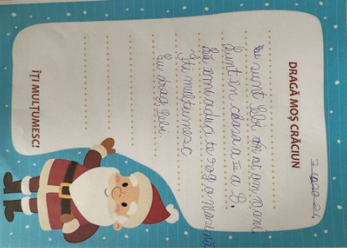
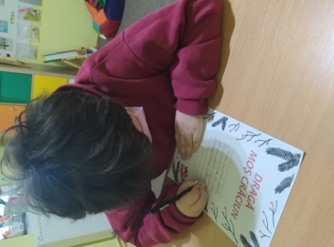
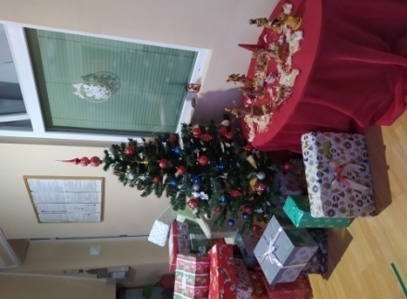
A warm thank you to all who have chosen to journey together with us in the spirit and joy of Christmas!

