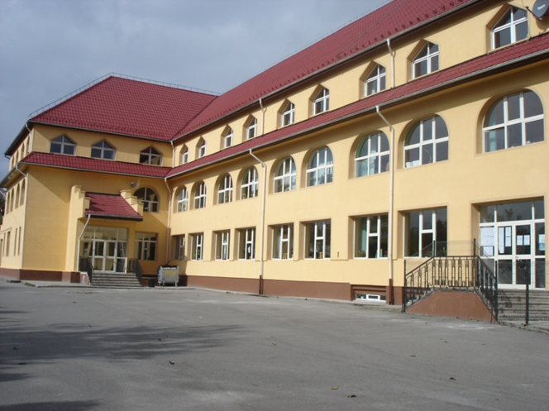

25th ANNIVERSARY OF SCOALA SFANTUL IACOB
CAMPULUNG

It is hard to believe that our school is 25 years old but it was very real on 15th October 2021 as we celebrated. Unfortunately, as the restrictions are still with us, they had an impact on the day as we weren’t able to have any visitors from outside the area and to make matters even more complicated Campulung went into a higher code of restrictions on 14th October but we were very pleased we were able to continue with a few more changes.
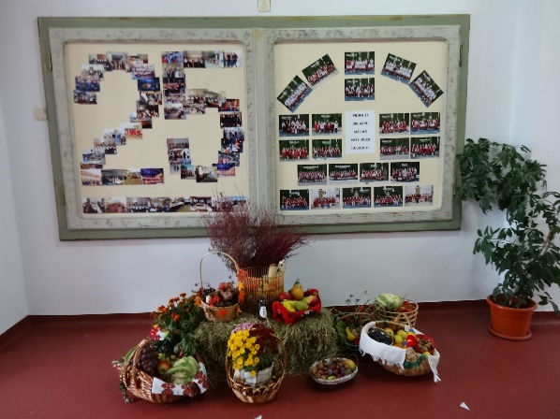
As is our custom now in school each autumn we celebrate the harvest with a display in school and then we distribute them to the needy. This year parents and staff were even more creative than usual.

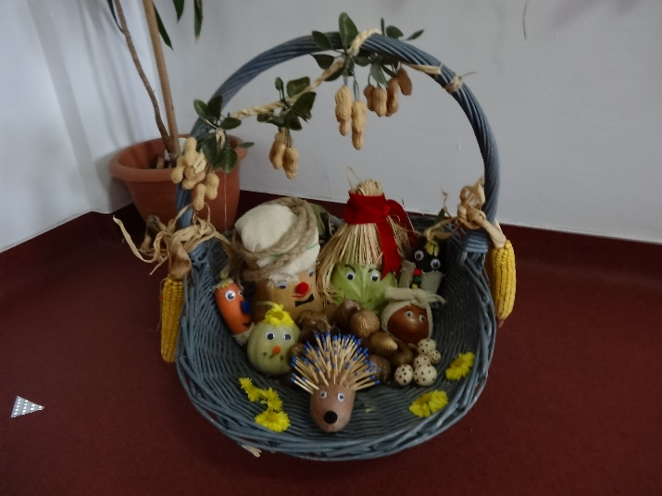
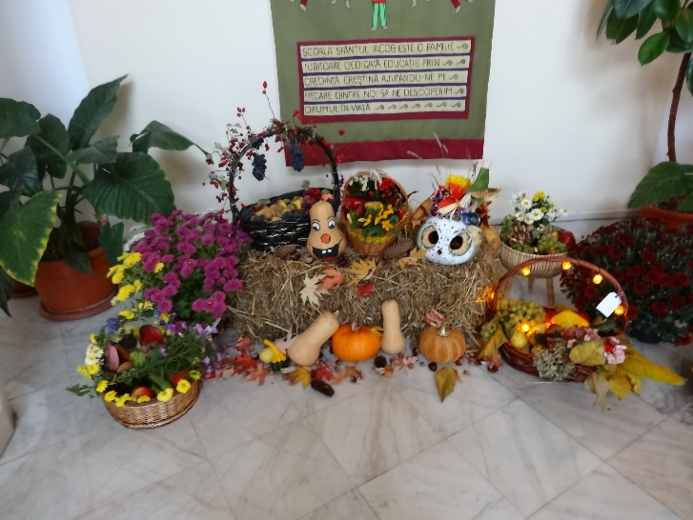

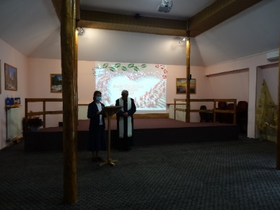
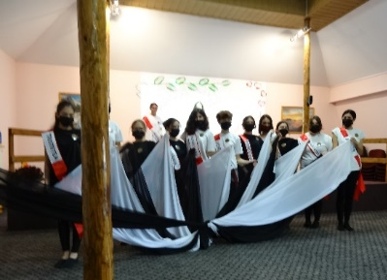
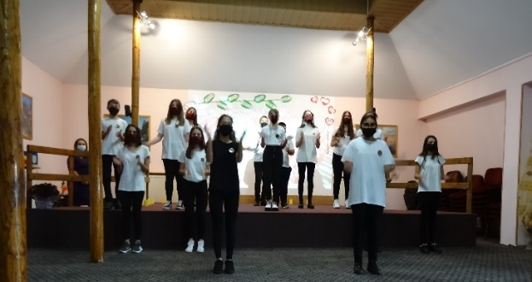
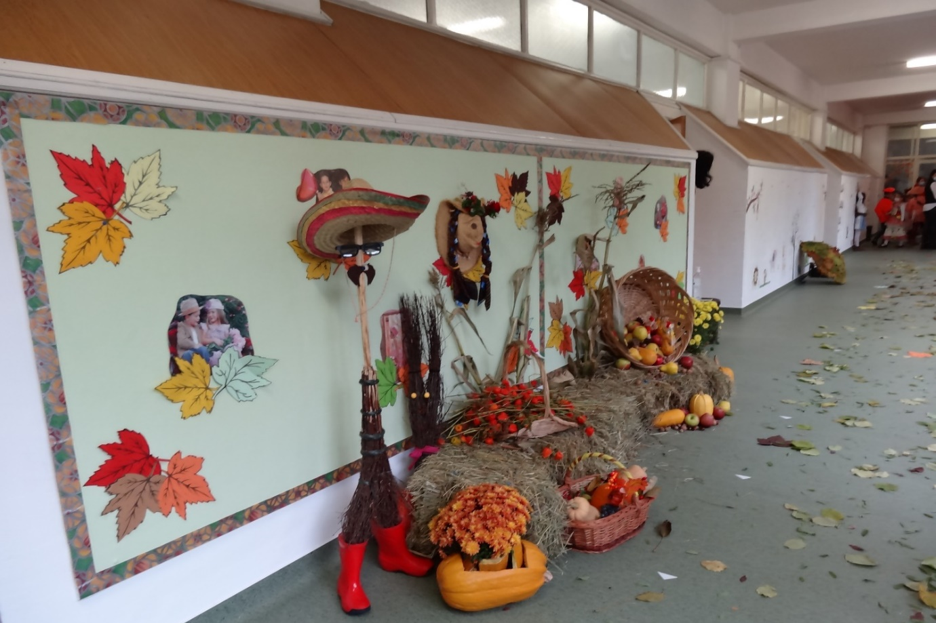
The children in the secondary school prepared entertainment for the visitors but again on a very reduced scale and these items were integrated into the speeches that are always necessary on such occasions. The bishops of Bucharest intended being with us but as they were not present Father Petru conducted the thanksgiving prayer service at the beginning of the proceedings. During his address Father thanked the Congregation for their initial and continued support of the school and he always recognises the impact the Congregation has on education in Campulung. The children performed songs and poems about the school and its short history. Girls from classes 7 and 8 entertained us with a very moving piece of theatre and dance based on both positive and negative emotions.
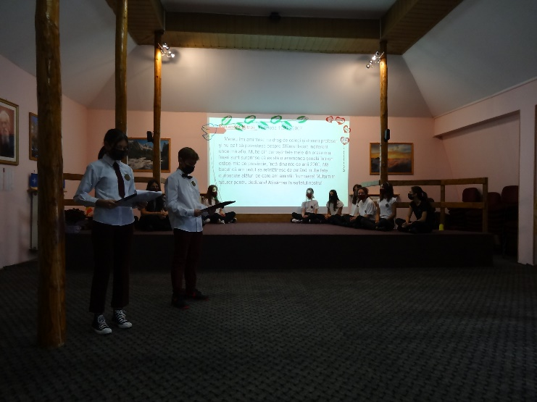
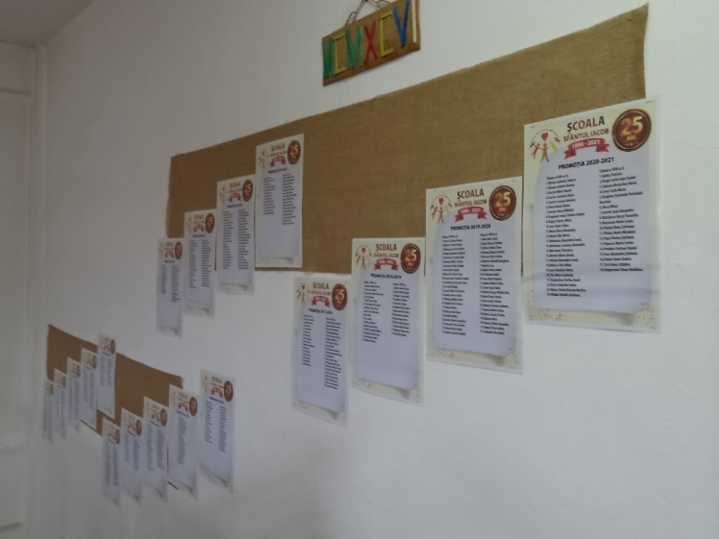
A parent congratulated us all on the achievements of our present and past pupils. One of our past pupils (from the first generation of pupils) also addressed the gathering and it was very moving to hear his appreciation of his time with us and for all that had been done for them as pupils. Many past pupils sent messages of congratulations and thanks. A summary of their messages were read.

The deputy mayor was also present on the day and added his congratulations and wishes for the school’s continued success into the future. As a local head teacher of a high school he commented on how our pupils were educated not only to a high standard but also prepared to take their places in society.

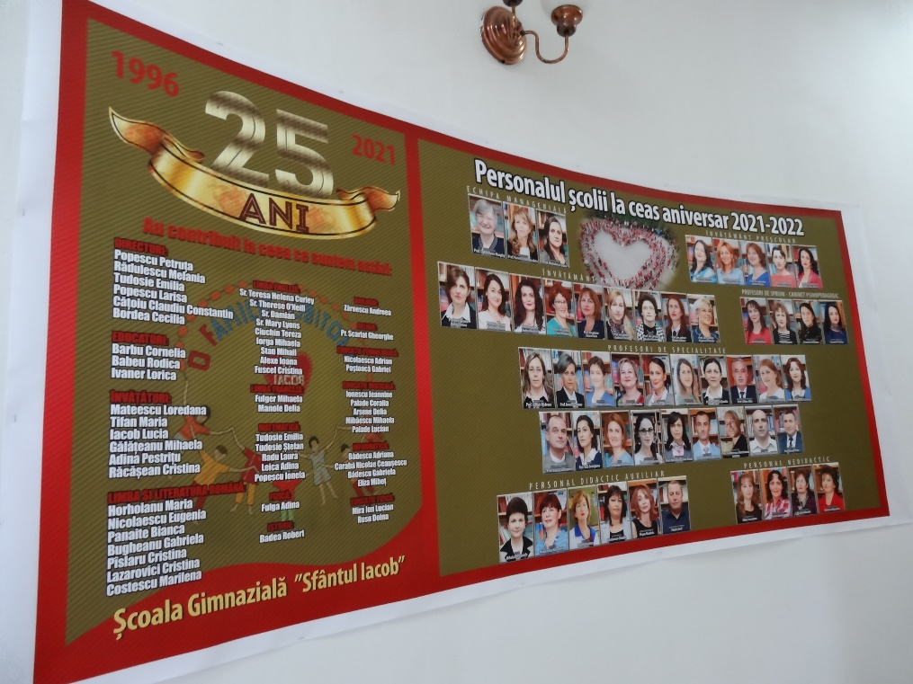
We had a banner made with the names of all our past teachers and photos of the present staff. Even though they could not be present it was nice to remember all past staff and recognise their contribution over the years. There are many sisters from the congregation who have helped us over the years and their names are displayed here.
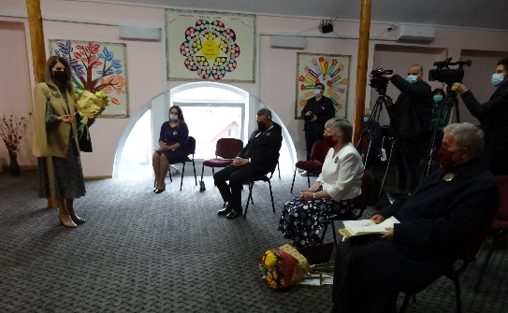
The director, Pastoric Irina brought the proceedings to an end with a vote of thanks to all present and involved in the various presentations.

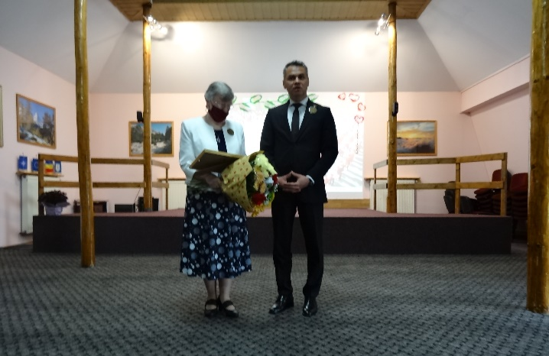
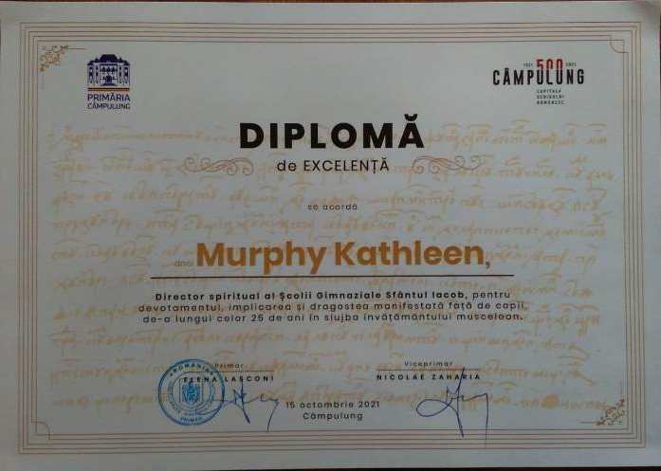
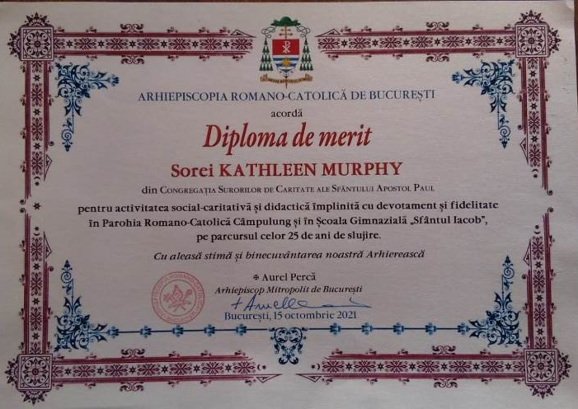
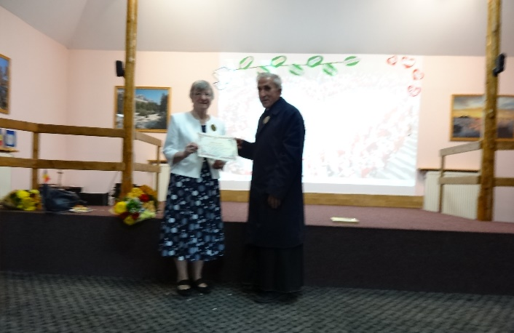
During the day I was presented with two diplomas. Father Petru, on behalf of the Arch-Bishop, presented me with a diploma of merit in recognition of the part played in the development of education in Sfantul Iacob and activities in the parish. The Deputy mayor presented a diploma of excellence for my involvement in education in Campulung. These are a recognition of the role the congregation has and is playing in our mission in Romania.
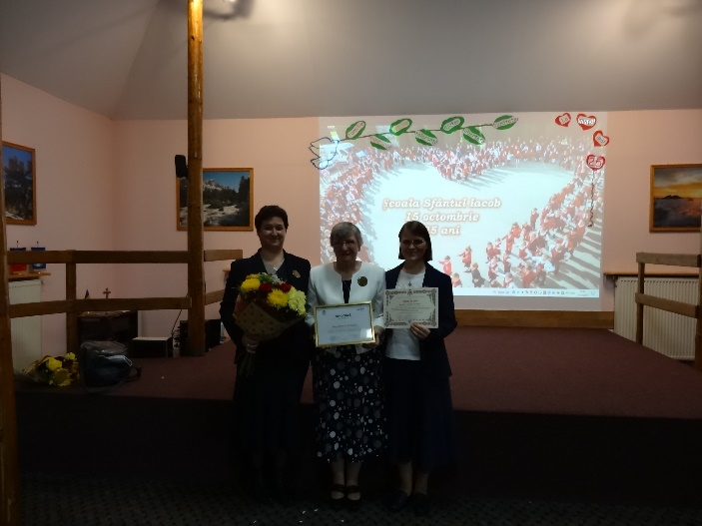

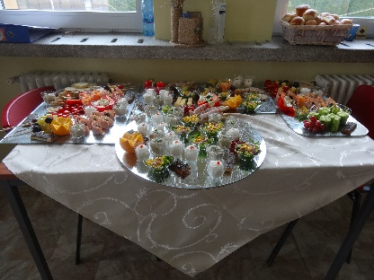
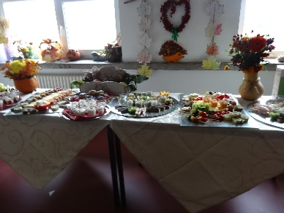
All were invited to enjoy the buffet prepared by the Caritas Impreuna Restaurant. This was appreciated by all present in the school on the day. To celebrate the day pupils and teachers organised different activities and spent a shorter time than usual in school.
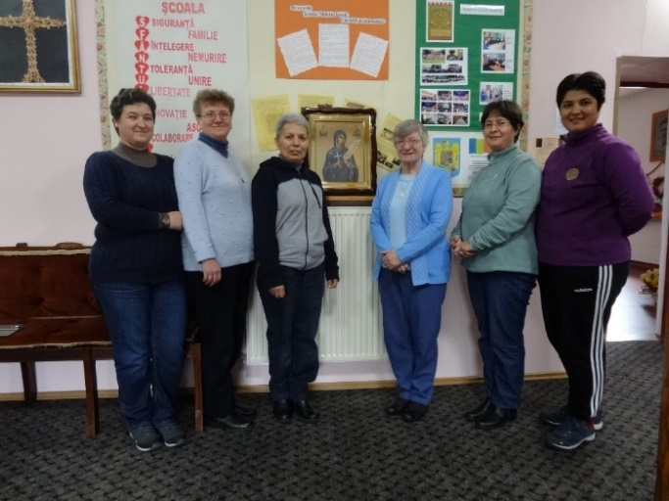
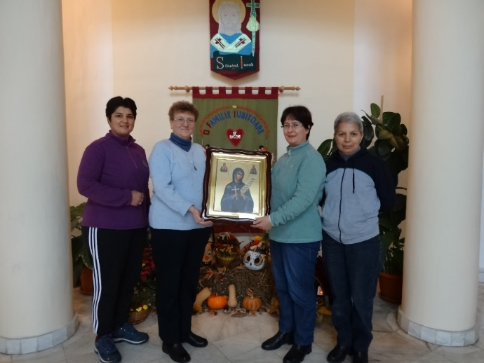

The sisters from Moldovia joined us for our celebrations. As Iasi had an even higher rate of Covid than Campulung had on the day, they decided not to come to school but to follow us on Facebook as all was transmitted live through the school face book by the local television network. We had our own celebration in the convent that evening. The sisters presented us with a beautiful icon of St. Paraschiva which we will hang in our school chapel. The sisters visited school on their way back to Onesti and Tomesti on the Saturday afternoon.
We had a busy but exciting few days as we celebrated an important milestone in the life of Sf. Iacob School.

Sr. Kathleen Murphy

