Outreach to the Homeless in lasi, Romania
Sr. Simona
Because of heavy snow I had to take a different route to work but God had a plan! As I walked quickly I thought it would be great to arrive at work early where I could have a cup of hot tea! The snow was knee-high at this stage. Suddenly before me were five old men wrapped up in some dirty blankets, sitting on the pipes which carried hot water to the nearby flats. I approached them and greeted them. They were frozen and were surprised that someone stopped to greet them and they were suspicious. Who is this person? I chatted a little with them and they told me that this is their ‘home’ in hail, rain or snow.
This image stayed with me all day and I who have a warm home was convinced that I had to do something about it. But many questions: how could I help them and how could I provide a hot meal for them during the freezing winter months?
I got in touch with Sr. Eleanor and asked her if I could use some of the money donated from Workington to buy hot meals for these homeless people who obviously had serious health problems. She thought it was great idea. My work mate who is a social worker and I went to a nearby restaurant and we discussed the problem with the manager. We met a very generous lady who agreed to give each of the homeless men a hot meal per day at a very reduced rate: £2.50. The meal consisted of a hot cup of soup, bread, and the main course, meat and vegetables. From November 1st 2017 these five homeless people received a hot meal every day. You can imagine what a difference that made to their lives especially when the temperature could be as low as -28° C.
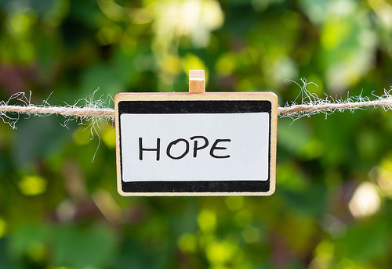
The project did not finish there! For the summer months we decided to stop paying the restaurant. Some of the men could do a little work in the market place and could produce food for themselves which they happily did.
We had a big problem with one man called Bogdan. He was very sick and confined to a wheelchair. Due to the extreme cold he got frost bitten and lost his toes. Because of lack of personal hygiene his feet became very infected with worms. Unfortunately, we could not find a doctor who would treat him because he hadn’t any papers and was living on the streets. We tried to take care of him ourselves for about four months, disinfecting the wounds and applying bandages but his condition needed professional care.
Several times we transported him to different hospitals but the response was the same – he was never registered and had no medical insurance so after a few days he was brought back to the street without having any treatment.
After much prayer and searching we managed to secure and pay for an Identity (ID) Documents for Bogdan and also bought medical insurance for six months. With the help of a social worker from Caritas we found a doctor who accepted Bogdan in the hospital. He confirmed he had no option but to amputate his leg. The surgery was a success and Bogdan was so happy because he had no more pain or infection. The Lord worked another miracle because we managed to place Bogdan in a State Facility where he is well looked after. He has begun a new life, no more freezing winters, no more hunger, no more pain. We can truly say that God has no hands, but he uses ours for reaching out to his beloved, he has no eyes but uses ours to see the suffering and our resources to save his people. Now Bogdan is a totally different man, he is very happy and he has a room which he shares with two other men whom he calls friends. He is grateful to all the people known and unknown who contributed in one way or another to change his life.
Now there are 12 homeless street people who receive a hot meal each day. We also have two volunteers who help from Monday to Saturday to distribute food. A seed was sown and is bearing fruit!

