Prayer – Share - Pizza
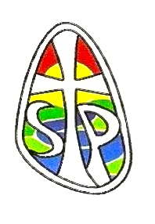
Considering a Life of Service as a Religious Sister

Need some time out?

Come and join us at St. Paul’s Convent, Selly Park

Saturday 13th October 2 - 5pm Sunday 14th October 5 – 7pm

Saturday 1st December 2 – 5pm Sunday 2nd December 5 - 7pm
Enquiries: Sr. Margaret Mattison.
Email: mags123@tiscali.co.uk
Sr. Patricia Murphy
Email: p.murphy45@yahoo.com
Sr. Kate Ryan
Email: ryankate66@gmail.com

