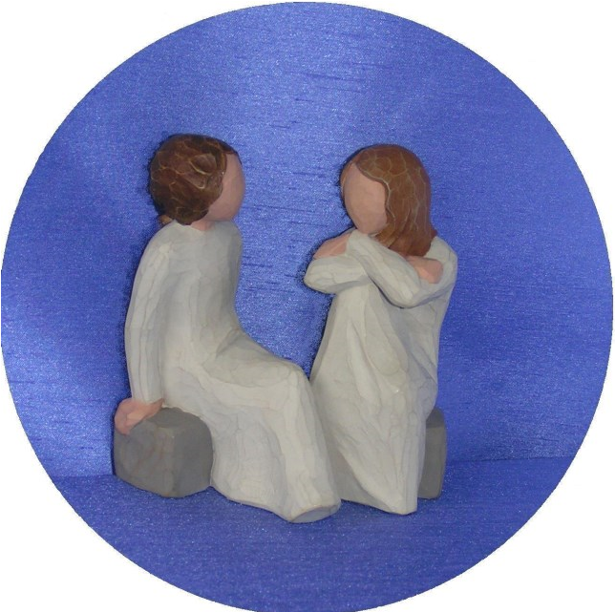
‘
We, the Associates

of the Sisters of

Saint Paul, inspired

by the Gospel, choose to

live the life of Christ and

to share it with others

in our world.’

N E W S L E T T E
R

Issue 16

Spring

2015

20
th Anniversary Celebration

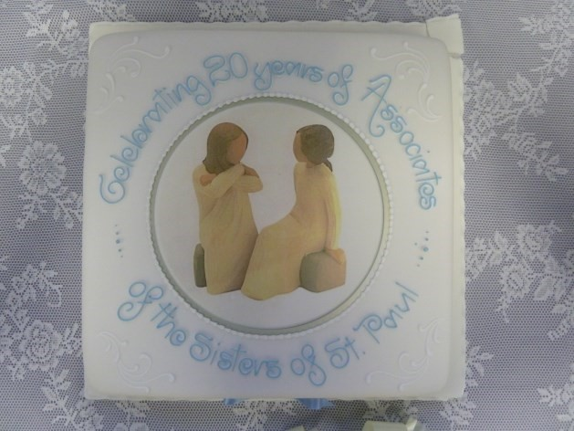
On the 8th November 2014 the Associates of the Sisters of Charity of St Paul the Apostle celebrated their 20th birthday. We invited Associates, some of whom were at the first Associates meeting, Sisters from the Community and Sisters who come to our gatherings when possible. Many came!
Earlier in the year, the Core Group had a meeting with Sisters Kathleen, Jean and Ann to ‘discuss’ Associates and how we might celebrate our important milestone and also a meeting with Sister Alice to help us organise details of the liturgy. Selly Park celebrations always begin with tea / coffee in the cloister and the opportunity to mix, chat and greet old friends and sometimes make new ones.
Sisters and Associates mingled, shared memories, congratulated and rejoiced with us. There was a most wonderful buzz of conversation, joy and celebration. We were all celebrating together. This togetherness was expressed in our Mass in the Chapel and our Lectio Divina and lunch in the Conference Centre. The day was truly blessed.
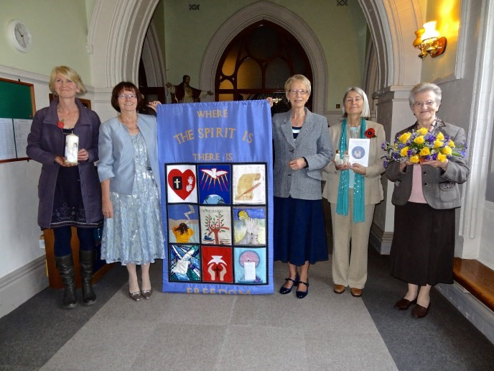
As we entered the Chapel for Mass we received our Mass booklet and a leaflet with a comment on each of our symbols: Candle, Heart and Soul and Banner. Our liturgy began with a procession into the chapel, which was led by an Associate carrying our Associate Candle followed by the Heart and Soul symbol, also carried by an Associate. The candle was decorated with our symbolic ‘HEART AND SOUL’. Flowers were carried by Sister Mary Clare. These beautiful flowers
were later placed on Sister Philomena’s grave. No doubt she would have been organising her own celebrations in Heaven with Associates and Sisters there!
Our banner was carried by two Associates and then hung in a place of honour on the sanctuary during Mass. Candle, heart and Soul and flowers made a fitting display in front of the alter.
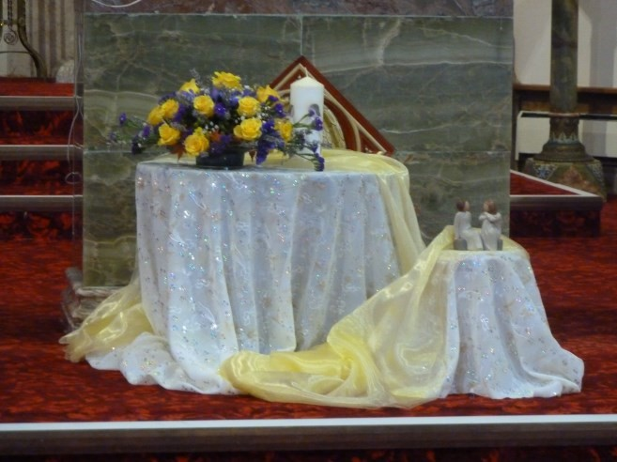
Father Christopher Handforth, Chaplain at St Paul’s, celebrated Mass for and with us and Sister Kathleen spoke words of warm welcome and affirmation of us as Associates of the Sisters of Charity of St Paul. Sisters and Associates shared the readings and offertory procession. Our Mass ended with that great hymn ‘Great St Paul’, during which we processed out carrying all our symbols with us. It was a fitting end to our wonderful liturgical celebration. We thank Father Chris for a special celebratory Mass. On leaving the Chapel, each one received a commemorative bookmark with (yes, you have guessed it) displaying our Heart and Soul symbol. We then retired to the Conference Centre for more celebrations. A feast of photographs was prepared by Sheila and beautifully mounted for all to see,
including photos of the very first group. Sr Mary Clare was missing from the photo as she was the photographer!!
So many memories!
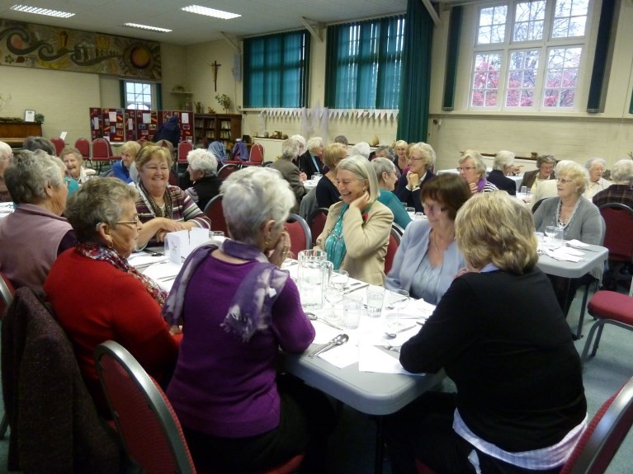
We feasted in style, soup from the kitchen, which we always look forward to, as well as a little more than sandwiches. We toasted with wine and orange juice after which we settled in our circle to celebrate and find ourselves in the Gospel of the day but not before we had lit our candle which had now become part of our Lectio display, a display, always inspiring.
It seemed very fitting to ask Frances Campbell to light the candle as she was part of that first group in that photograph taken by Mary Clare. We read the Gospel, echoed the word, had our time of silence to reflect on how the Gospel spoke to each of us and, as always, shared whatever we wanted to share.
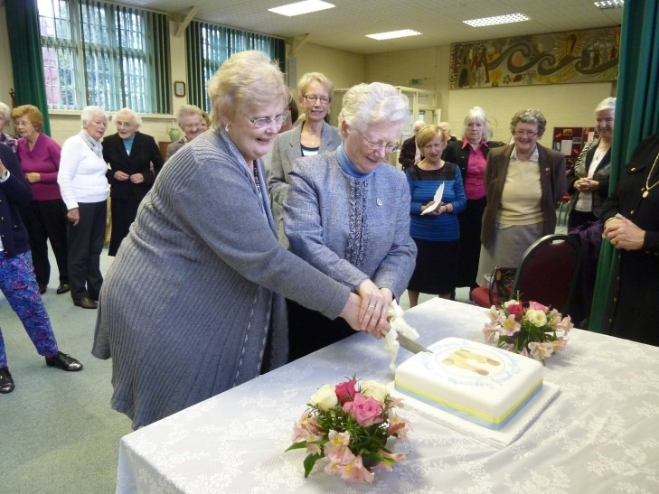
Our day would not be complete without tea and cake. This time the cake was special, decorated as it was with the Heart and Soul symbol, and symbolically cut by Sister Kathleen and Mary Brandwood. Mary was also on that first historic photo. Chunks of cake were carried away so that other Associates who could not be with us, could also share in the celebrations. The end of a perfect day as we said our goodbyes and prepared to depart. BUT there was a last surprise, literally in the heavens. Just as the last few were about to leave, we looked out of the window and saw the most perfect rainbow that anyone could see. Sheila, always ready with the camera, rushed out and the photograph is there to tell the ‘story without words’. Clearly, there was rejoicing in heaven too.
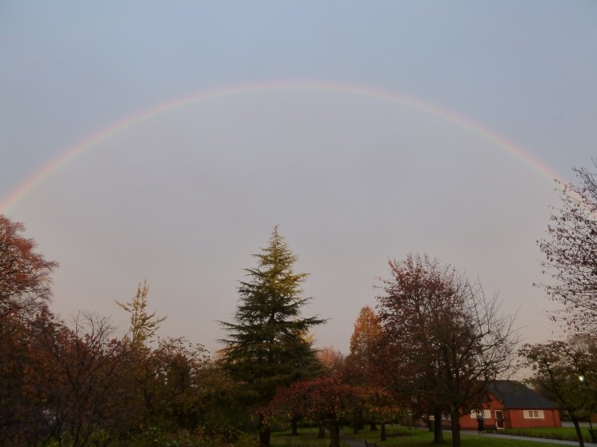
OUR THANKS
There are always people to thank. Our thanks to Sister Kathleen and team and to Sister Alice for helping us to have a memorable celebration day. Thank you, too, to Sister Dympna and the community of Selly Park. We thank you for the warmth of your welcome, hospitality and the inspiration that brought Associates into being. And to the Sisters and Associates who could not come but sent messages of blessing and congratulations.
We thank ourselves. So many Associates gave of their time and talents to create displays, prepare booklets and bookmarks, brought food and drink…….
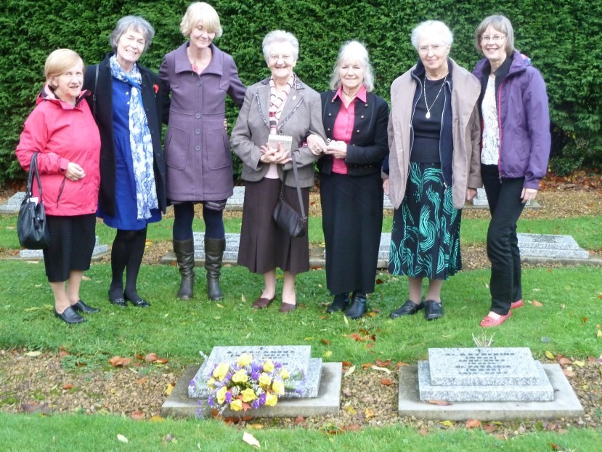
How can we thank Sister Mary Clare and Sister Philomena for simply giving us the Gospel and in so doing have transformed so many lives?
We are truly blest.

Anne Cartwright

150th Anniversary of the Sisters of St Paul the Apostle

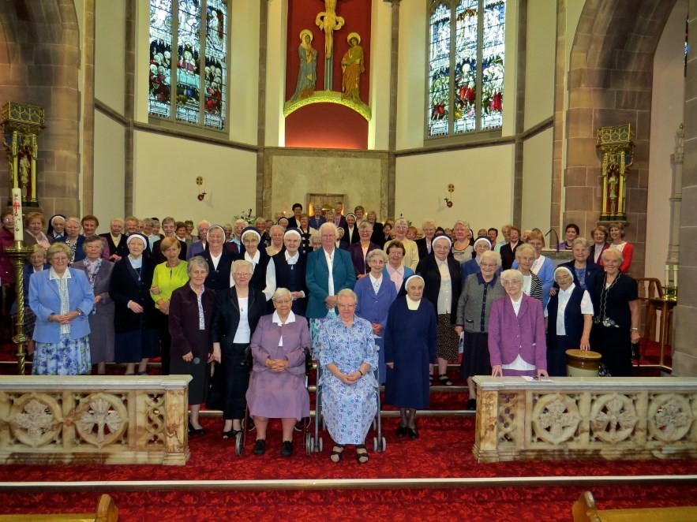
October 14th 2012 was an important landmark for the Sisters of St Paul as they celebrated two major historical events in the story of the Congregation – the arrival of the Sisters to Selly Park 150 years ago and the 100th anniversary of the laying of the foundation stone of the convent chapel in Selly Park.
Associates were invited to be a part of this very special occasion and those of us able to be there were soon caught up in the atmosphere of celebration and thanksgiving. But would this be a “Selly Park Day”? Associates were, as always, concerned about the weather. Dull, to say the least. For any Associates unsure of the definition of a “Selly Park Day”, any rain or even dull weather is trusted to give way to brighter or even sunny conditions as the day progresses. We have not often been disappointed but we would see!!
Following a warm welcome and reflection from Sr Kathleen, the morning began with a celebration of Mass. The Chief Celebrant was Bishop Robert Byrne. Sr Alice and her camera were working overtime to produce the perfect photographic record – helped at various stages after Mass by Sheila and the Bishop. The Mass was a wonderful reflection of all that the past has been and the expression of aspirations for the future.
Lunch was a very happy occasion with much chatter over delicious food prepared by the new chef and his team. There was also time to look in detail at the displays and to appreciate the research done by Sr Anne Cunningham.
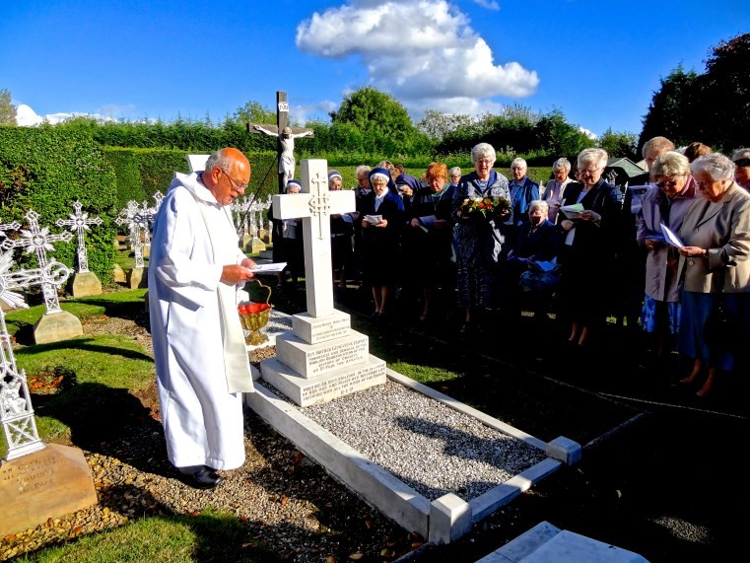
In the afternoon, Fr Christopher Handforth, Chaplain to the Congregation at Selly Park led us in a prayerful liturgy, after which we processed from the chapel to its foundation stone for a prayer of blessing on its centenary in that place.
Then on to the cemetery. We gathered around the grave of Mother Foundress, Genevieve Dupuis. Prayers of gratitude for all that she had achieved in a life so full of faith and vision – and sometimes against all odds – were said.
At this point, I was very much aware of being surrounded by
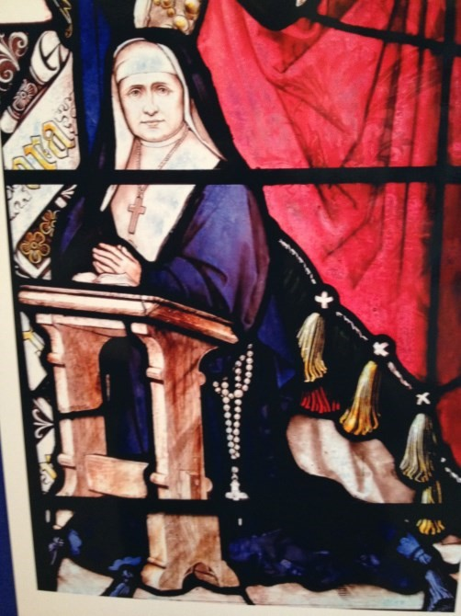
the graves of so many Sisters of St Paul, now at their rest, who have touched and shaped my life (especially as a young teacher!). I know that I speak for countless others in saying this. The graveside service ended as we sang “Standing on the Shoulders” – the words of Joyce Johnson Rousen, which speak of the legacy that has brought the Congregation to the present day. May they go from strength to strength, working as they do in a very different world but with an unchanging charism, something of which Associates would seek to share. So was this a “Selly Park Day”? As the sun made a fairly brief appearance in the afternoon we know that we are very blessed and yes, it certainly was!!

Maureen Cooper

Coventry & Leamington Associates Retreat day

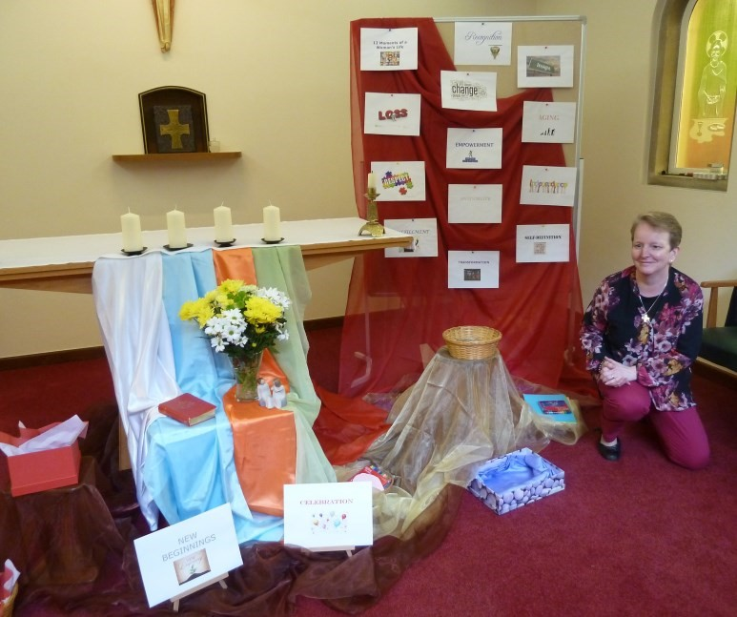
It’s 6.30 am and still dark outside, and my little dog is taking me for a walk! The weather’s unpromising, very cold, windy with that fine drizzle that seems to get to places you never knew you had! I wondered if others, like myself, had given a fleeting thought to the day ahead; but decided that a “blank canvas” was the best approach, though I was aware that there would be an on-going theme of “Women of faith”, with particular reference to certain women of the Old Testament. Off home for our breakfast, then with my canine companion was to spend the day with friends. So was I.
About 9.40 am I arrived at the Convent of Corpus Christi for the
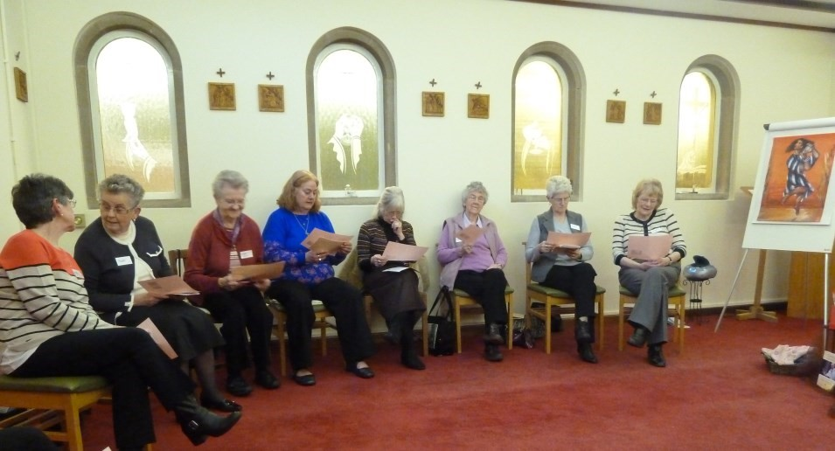
Retreat Day for the Associates. The sky had cleared and brightened, though it was still very cold. I entered the Convent with three other members of the Associates and we smiled in greeting. We were then greeted in turn by Sister Josephine from the convent, Sr Ann O’Sullivan, a Sister of St Gildas, who was to lead the day, and Sheila who was busy in the Chapel putting finishing touches to an impressive display relating to the Retreat Day. By 10 am we had all assembled for hot drinks and a splendid display of biscuits. I’m sure I wasn’t the only one to be pleased that Lent had not yet begun! We all had little badges with our names on, making it much easier to recall who was who (nice idea)! By this time the sun had put on a very smiley face,
and we were already to begin.
Sr Ann introduced herself and briefly outlined the day ahead. There was certainly a sense of anticipation in the air. A box of scarves was handed around and we were asked to pick out the one which we felt most drawn. Amid the good humoured banter and comments such as “I was going to choose that one!” or “Oh! I like the colours on that”, we all managed to find one that strangely enough was appropriate to each of us. After we thought a little on our choices we were invited to say why we were attracted to a particular one. Everyone found something relating just to them, in the patterns, colours and shapes. This was a super little opener to the Retreat.
HEARTS AND STONES: Little coloured glass hearts were presented and Sr Ann asked us to choose one or two and then tell the group what positive feelings they imparted. Ideas varied from feelings of gratitude for the love and comfort of family and friends, birth, celebration, remembrance, the establishing of the Associates and being asked to join them. (Mine!). Later, when asked to choose the “Stones” we looked at those things which may have caused obstacles, set-backs, upset or problems along the path of life. These ideas of “hearts and stones” gave us a chance to illustrate with a drawing or diagram on a piece of paper, something which was particularly meaningful to us as an individual.
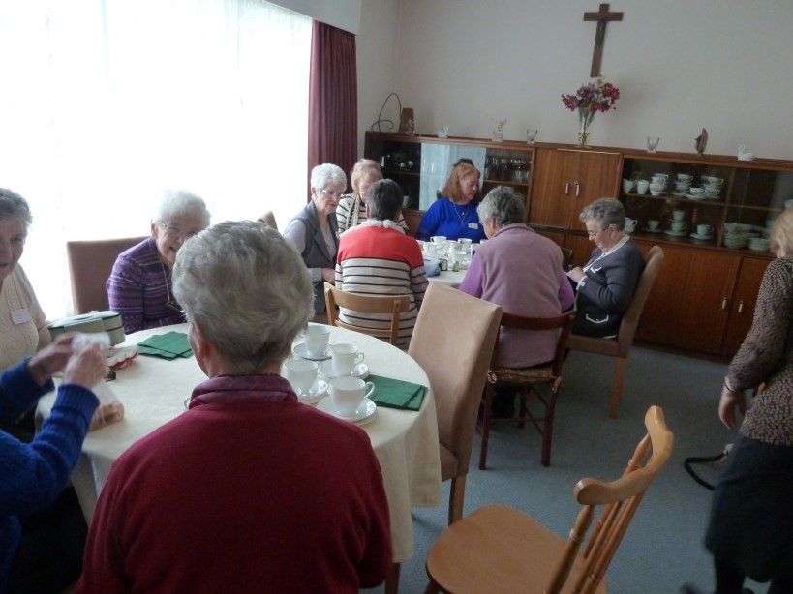
When we stopped for lunch we were delighted to be treated to Sr Josephine’s “Souperior” soup as an accompaniment to our own packed lunches. I can still savour that soup.
Definitely “yummy in the tummy”.
Our day then continued in the Chapel where we split into two groups to look at women of the Old Testament. Esther and Judith both proved popular, particularly as they were the embodiment of faith and trust in God and in putting that trust into their actions. They were fully aware that God was their support and shield. We looked at the story of Judith in more detail and how, through her actions, she saved her people Israel from almost certain annihilation at the hands of Holofernes and his vastly superior armies. She was not afraid to approach God to remind Him that He had always defended those who trusted Him. She gave the elders a strongly worded telling off for tearing at their garments and complaining that God was not helping them. Judith was not about to allow a group of complaining men get away with this attitude! So she “went to war” on behalf of her people, full of faith and trust in God, a nice little outfit, bit of jewellery, perfume and some homemade cakes. She returned from the enemy camp with the head of Holofernes in a bag. Truly a woman of strength and courage, but above all, a woman of faith and of joy.
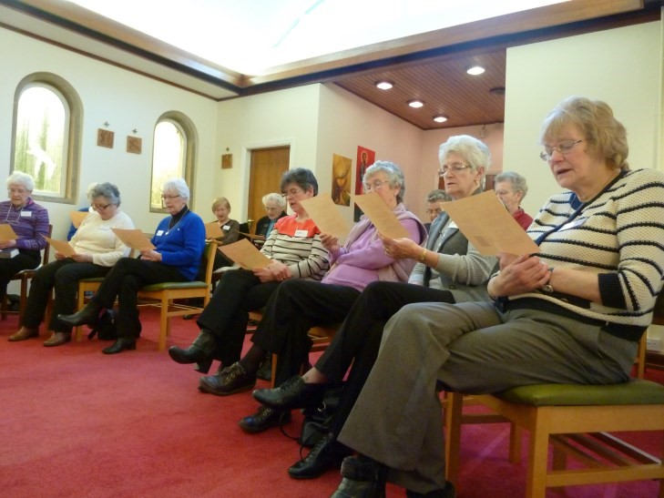
On a board in the Chapel words had been written on slips of paper. These related to human growth and development at certain stages in life. For example, beginnings, loneliness, loss, aging, invisibility, joy. We discussed in our groups some of these suggestions especially that of loss. Not just the loss of those whom we love or care about but loss of respect, trust, faith. This was a very thought provoking exercise. As a balance to this we then paired up to look at particular joyous moments. It was lovely to hear how many of us were able to pin-point and describe a joyous moment special to us.
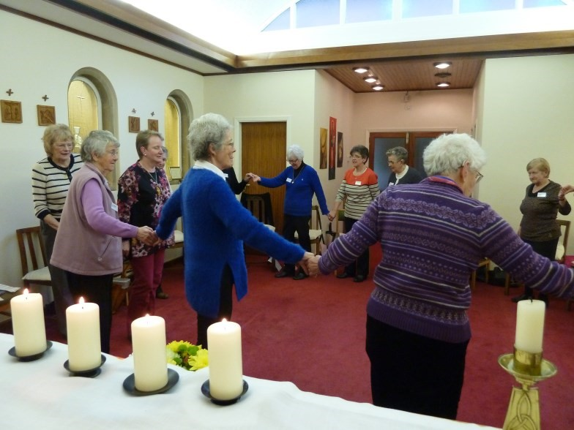
Recalling once more women of the Old Testament, we had the chance for a little dance ourselves, remembering Esther’s dance of joy and praise. Simple little steps to music, but a warm feeling of sharing a special moment with others, and good fun too. It was a welcome break from the concentration and special thought we had given to our list of questions, which Sr Ann had asked us to consider and write our comments on. Psalm 27 had been chosen by Sr Ann for us to speak and think about. “The Lord is my Light and my Salvation, whom shall I fear?” (Verse 1) and “Hear my voice when I call, Lord” (Verse 7). These verses tied in so well with the themes we looked at throughout our Retreat Day. We see the role of prayer, humility,
faith, hope, complete trust in God and of joy. I will remain confident of this: “I will see the goodness of the Lord in the land of the living” (Verse 13).
The glow of the sunshine outside made the little Chapel warm and that warmth was matched only by the sisterly feeling within the Chapel itself. Here were women of different ideas and thoughts brought together by a very special bond. Those who had gone before us, ourselves and those yet to be. “I am standing on the shoulders of the ones who came before me. I am stronger for their courage, I am wiser for their words”. Our closing prayer brought all the strands of the day together. The roads we travel are many and varied but in the end our Journey of Faith will result in Joy!
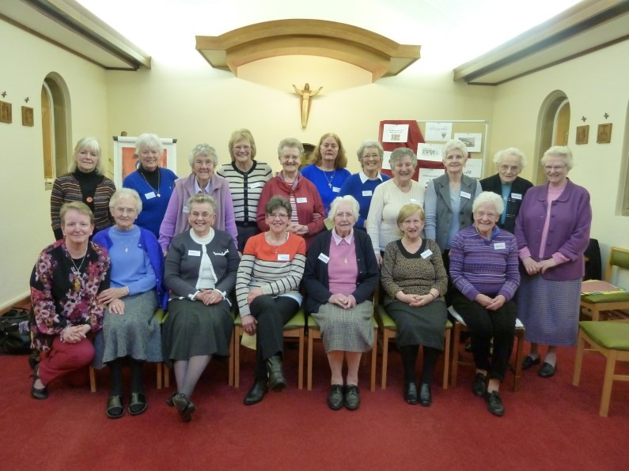
Our Retreat Day for Associates, though at times tiring and intense, was thought provoking, good humoured, reflective, funny and without doubt and overall joy. We studied women of faith and trust and looked at the hearts and stones encountered in our lives. We saw the great importance of reconciliation and the many roads travelled and which ultimately lead to God; if we are prepared to travel in faith, trust and joy, just like Esther and Judith did of old and like the Associates do today. We may all be different women but we are truly “sisters”. “We can see beyond the struggles and the troubles and the challenge, when we know that by our efforts things will be better in the end”.
Patti Hynd-Anderson

12 Moments of a woman’s Life

Before looking at the following, spend a little time reflecting on your life, being aware that God has always been at your side supporting and encouraging you, even though at times you may not have felt his presence. Be open to what God has to say to you during this time. Stay with one or two of the moments that you are being drawn to reflect on.

1. Loss
Loss throws us back on our own resources—our inner strength and faith.
It invites us to question what life is really all about. What does your life mean to you?

2. Change
Change always brings about invitation, how do we react, what gives us strength?
“We live in the womb of God, who is changeless whatever the situation we find ourselves in”.

3. Transformation
Transformation is a process of coming to wholeness. What does that mean in your life? What are the negative patterns in your life that slow down transformation?

4. Aging
“Age is a mirror of the knowledge of God” — what do you see when you look in the mirror? Who are the wisdom figures in your life & what pearls of wisdom can you pass on?

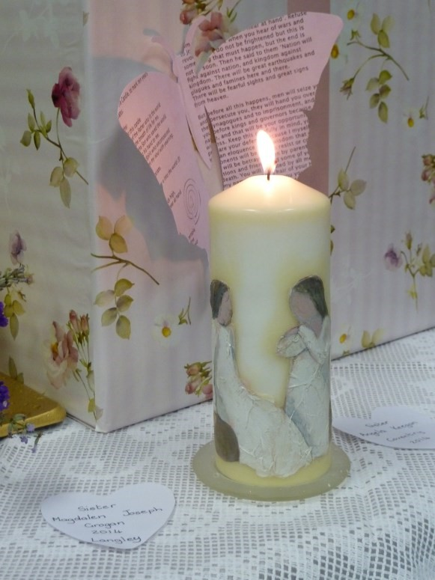
5. Independence
What is your claim of independence?

6. Respect
Women have rights, are strong, capable and independent human beings. How does this reflect on your life experience?

7. Recognition
In what ways can you help change society’s attitude towards women?

8. Insight
Do you take enough time in your life for moments of reflection? Where have moments of insight led you in your life?

9. Empowerment
What areas of your life have you or do you now feel empowered?
What are the difficulties you may face with empowering yourself?

- Self-Definition
What would you say self definition means to you? What are the challenges?

- Invisibility
Have there been times in your life when you felt invisible? What helped you through these times?

12. Fulfillment
What has helped you reach fulfilment in your life?
What have been the challenges and the joys as a result?

