Birmingham, Annie Bright Weston House

Brief History

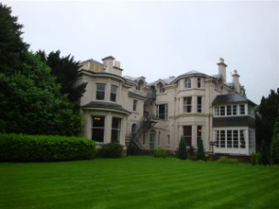
Mr. P. J. Weston bought a property on Wake Green Road, Birmingham in 1944 and lived there with his wife.When she died he wanted the house to be used as a home for the Aged and he wanted it to be named Annie Bright Weston House, in memory of his wife.He created a Trust for this purpose and conveyed the property to the Archdiocese of Birmingham.

A Committee was established and the home was opened by Mr. Weston’s daughter in 1949.The Catholic Women’s League ran the home until 1953 when the Sisters of St Paul were asked to run it.Mr. Weston continued to support the home financially and always had a great interest in it.Mr. Weston died rather suddenly in 1960.

In 1965 the Home was moved to Diocesan premises, in Norfolk Road Birmingham.The Diocese refurbished the house and installed a lift; money which Mr. Weston had given for the home was used to help fund the renovations.

Mr. Weston’s family continues to support the Home.
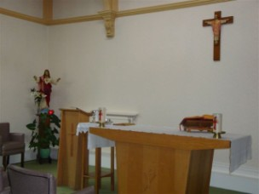
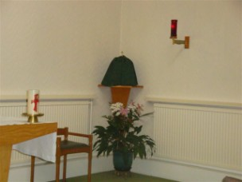

Apostolate in Annie Bright Weston Home

As Sisters of St Paul our mission here in Annie Bright Weston House is care of the elderly.We have dependant ladies who come to us expecting a happy and peaceful retirement in their last years.

We offer them a beautiful home situated on the outskirts of Birmingham city centre.

We have lovely landscaped gardens where the ladies can relax and enjoy the peace and quiet.

With the help of a well chosen staff the Sisters care for the residents. We show them the love and respect due to them so that they are supported and reassured in their years of retirement.

We are especially careful to ensure that the residents have the spiritual help they need in these years.

We try to ensure an atmosphere of peace and serenity in the house.

Our apostolate extends to all our staff and to the relatives and friends of our residents.

www.birminghamdiocese.org.uk

